**LaptopHarbor**



**GROUP MEMBERS**

**SUREMA QADEER**

**Student1417806**

**RAFIA NAJAM**

**Student1358888**

**ABDUL WASAY**

**Student1414752**

**ALISHBA KHAN**

**Student1429443**

CURRICULUM

**7062**

BATCH

**229F2**

FACULTY

**Sir. Usama Riaz**

CO-ORDINATOR

**MS. MADEEHA FATIMA**

**MAIN PAGE**

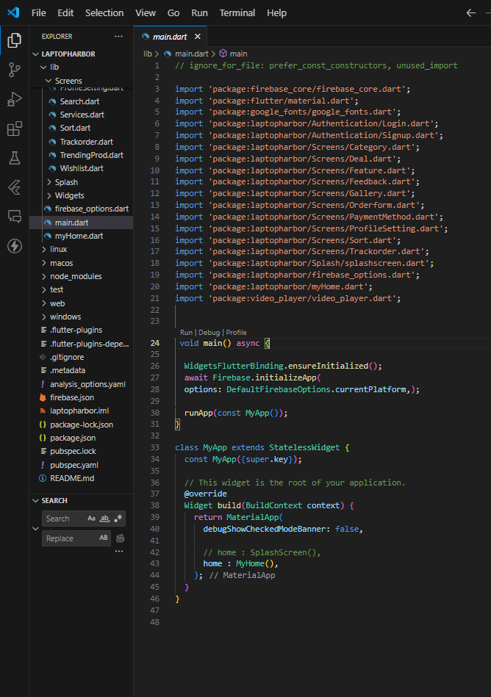

**HOME PAGE CODE**

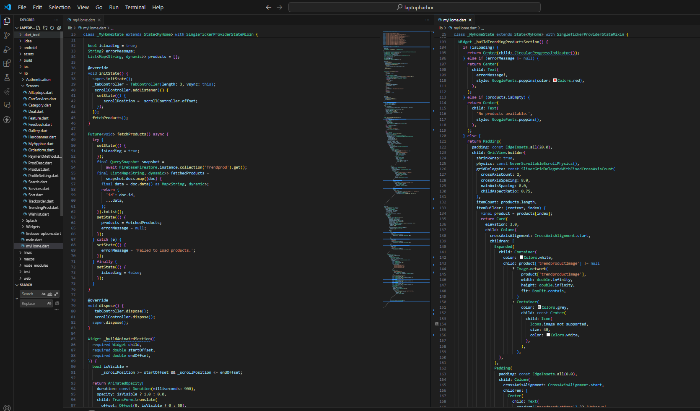

**FEATURED PRODUCTS**

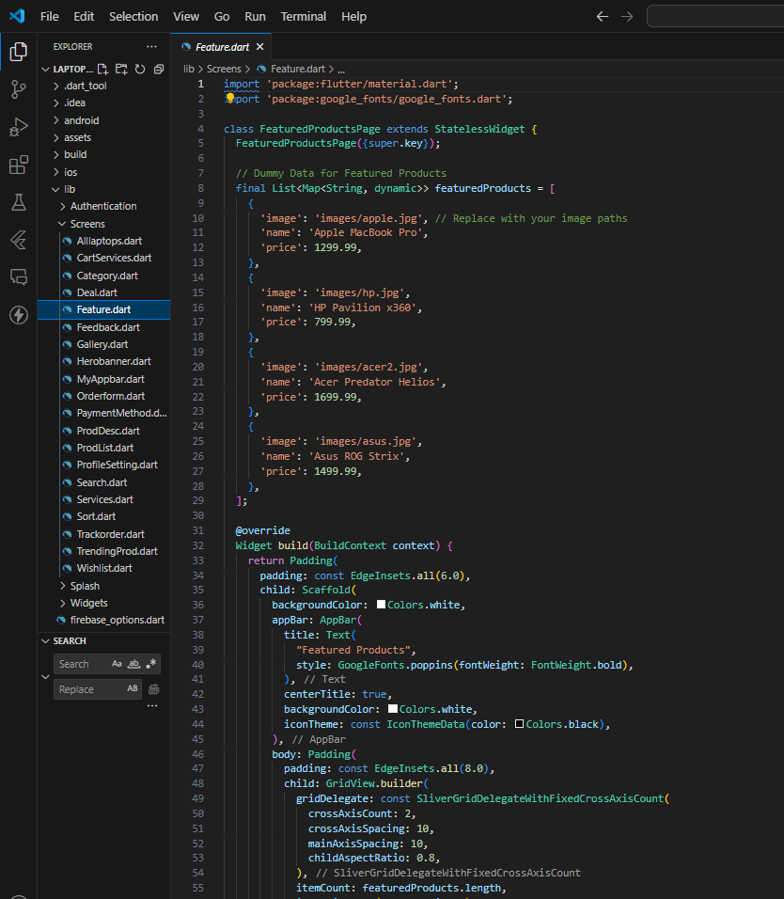

**CATEGORY PAGE CODE**

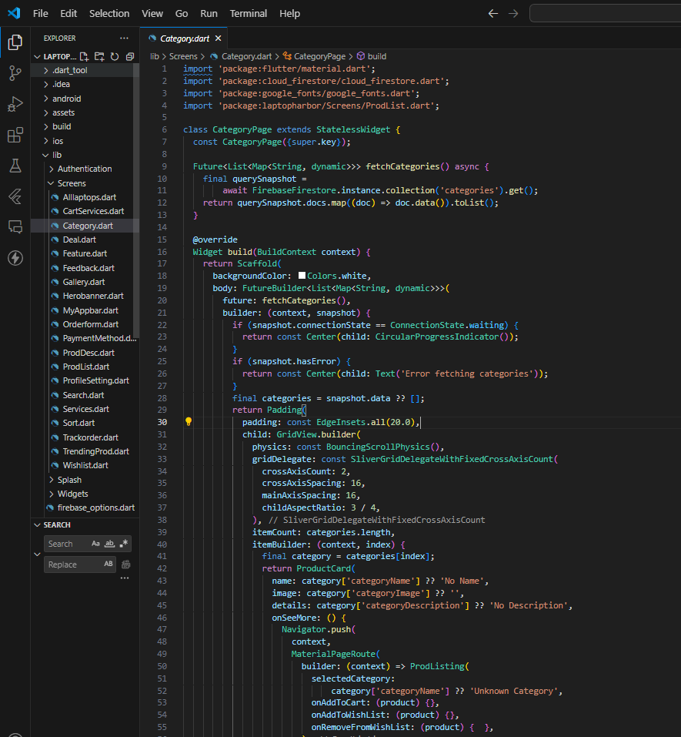

**ADD,UPDATE & DELETE PRODUCT IN ADMIN**

**PANEL**

**ADDED USERS**

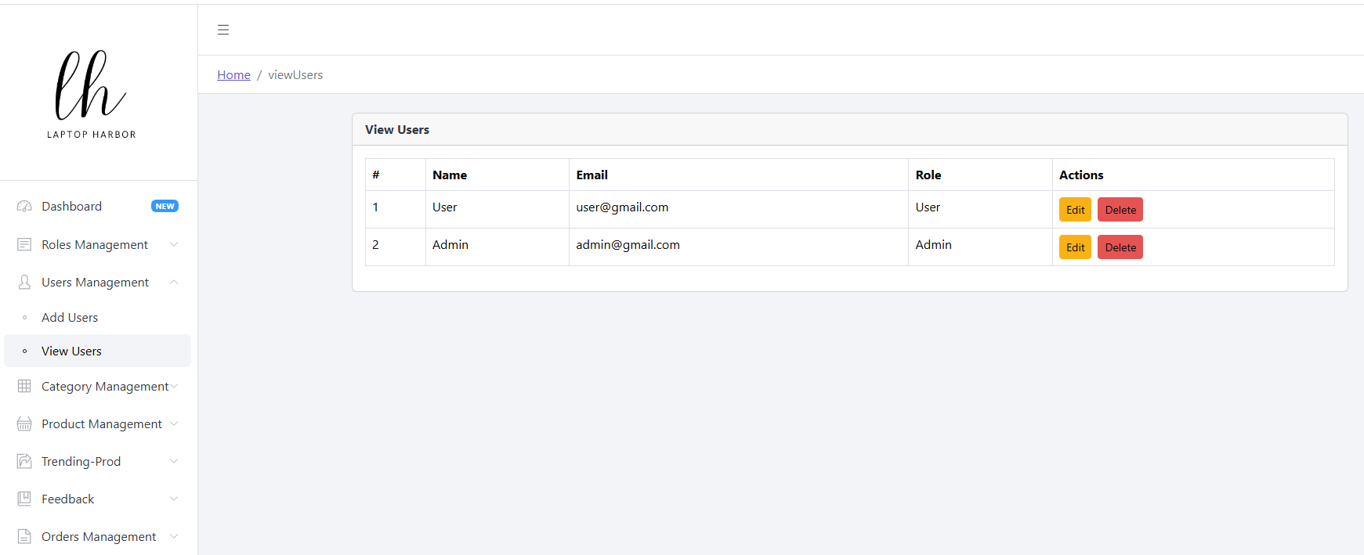

**ADDED CATEGORIES**

